Radiation Source Detecting Robot

Madeline Macalister, Nathan Segar, Nicholas Scott, Victoria Rowe, and Lena Asprinio

University of Rhode Island, Kingston, RI

The Radiation Detecting Robot was presented by Dr. Bahram Nassershariff at the University of Rhode Island to extend upon a pre-existing project as part of Special Problems MCE492. The project challenge was given with minimal set-goals, inviting ingenuity and creativity from Team 01 in solving the problem. Coinciding with the prior year’s work, the criteria of 12ft-by-12ft room expectation, in a 30-minute operation window, was implemented. The robot must be able to avoid potential obstacles in its path, while remaining autonomous. Additionally, it must be able to detect radioactive sources/ spills in the room accurately, and relay that data in a literal way.

I. INTRODUCTION
Radioactive materials are materials that are made up of unstable atomic nuclei that release energy in the form of ionizing radiation as they decay. This decay can either be through the emission of alpha or beta particles, or gamma waves. Each of these decay types have varying penetration power, shown in Figure 1.
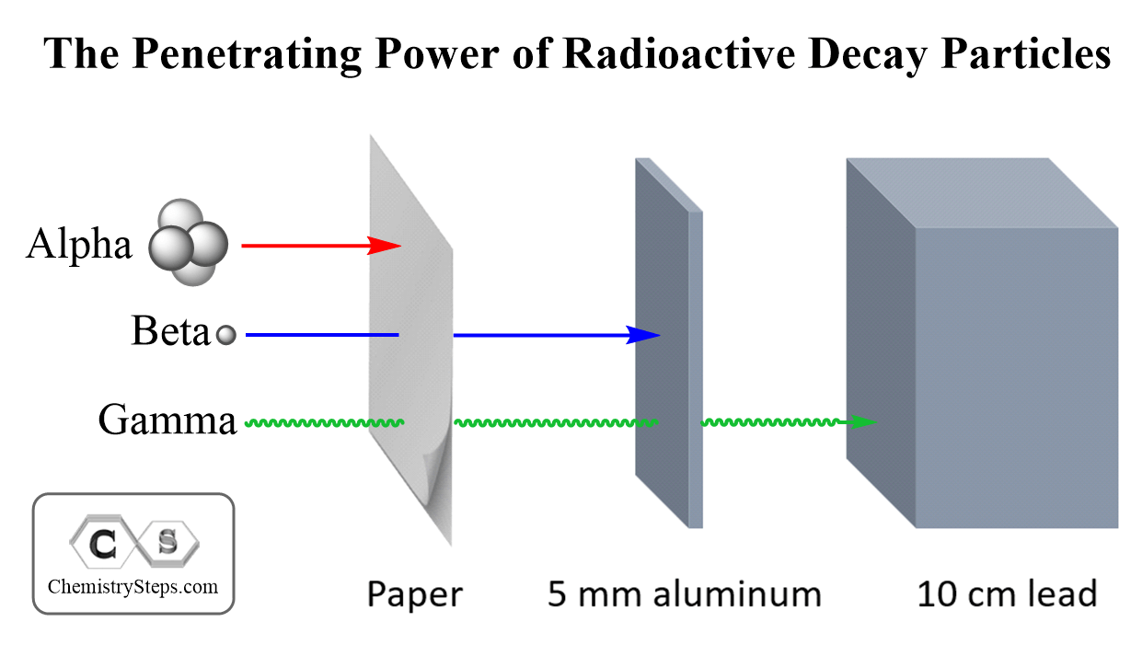

Figure 1 – Diagram of Penetrating Power of each Decay Type
Source - Gevorg, 2023

These materials have various uses in the medical and industrial field, as well as being of interest to researchers. As with any substance, there is a risk of spillage. However, due to radiation from these materials, determining the severity of the spill can be challenging and potentially dangerous. The current method is to send a volunteer into the area with protective equipment and detect the radiation level. Naturally, this poses a serious health risk to the volunteer and can take significant time depending on the size of the search area. A robot would greatly reduce the human cost of spillage detection, as well as making the process more efficient.
The team was tasked with developing a robot that could scan a 12 foot-by-12-foot room and find the radiation source in the span of 30 minutes. The robot must avoid any obstacles and be entirely autonomous and must accurately relay the data back to determine the source location. The robot will use the LUDLUM 9DP compensated ion chamber as the detector.
I.A. Prior Project Development
As shown in Figure 2, the team evaluated the previous robot to determine which features could be implemented into the new design, as well as what needed to be reworked.
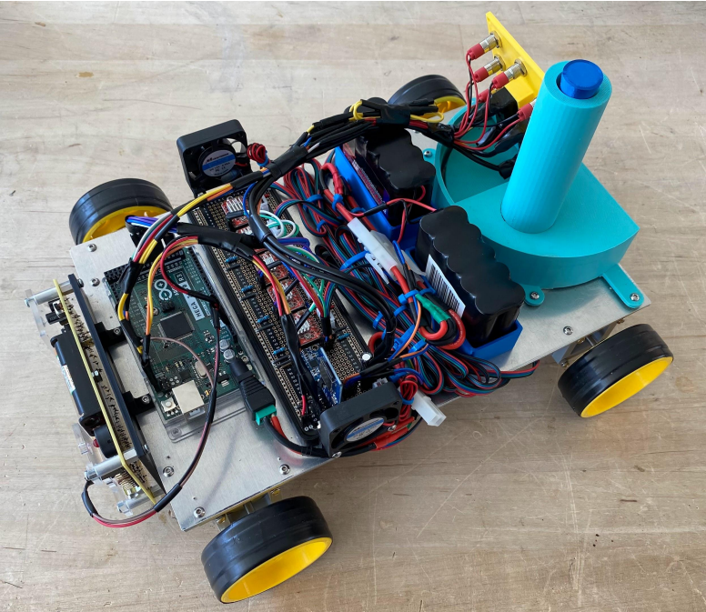
Figure 2 – Previous Team’s Robot
Whilst the general build of the previous robot was word. There were several areas of improvement. Firstly, new tires had to be developed due to the minimal traction on the original design. The wheels must also be able to support a much larger detector compared to the previous iteration. The steel plate on the robot base added unnecessary weight to robot and would be removed from the new design. The dropper mechanism to show where the source would be changed to a more sophisticated method. Wire management would be improved, as the previous robot had minimal making it difficult to determine the purpose of each wire. Finally, the fans on the robot were redundant as the motors would not be producing enough heat to warrant them due to the short run time. Additionally, they also used excess room and added unneeded weight to the robot.
While there were several areas of improvement found in the previous robot, there were aspects of the design that were utilized in the new design. These were the motors and the sonar sensors. Due to time and budget restraints, it would have been difficult to find and order new motors that were satisfactory for the project. Analysis of the motors from the previous robot concluded that they would provide enough drive for the new design to achieve the desired results. The ultrasonic sensors on the previous robot were also reused for the new design, as ultrasonic sensors were considered appropriate for the uses of this robot.
I.B. Preliminary Objectives
The purpose of the project was to create a self-operating robot capable of scanning a 12ft x 12ft room within 30 minutes without external control to determine if and where any radioactivity is present in the area. A previous solution that was unable to meet the requirements was provided to the team to provide design inspiration for the new project. A LUDLUM 9DP compensated ion chamber was also provided to the team to serve as the radiation detector for the new design.
Area mapping and visual radioactivity position marking were also requirements for the final design. Sonar detectors from the previous robot were integrated into the design for area mapping, being a simple, cheap, low-energy solution. Data collected from the 9DP during operation was converted into a graph that provide a user with information on where radiation sources were detected, if at all.
II. DESIGN PROCESS
II.A. Preliminary Design Iterations
- Previous designs that were changed
II.B. Final Design
The final design assembly, pictured in Figure 3, consists of a 3D printed body, with separate compartments for the radiation detector and electronics. The body was printed in X different parts and screwed together, due to the size of the 3D printers used and the shape of the body. The sides of the design feature holes that both maximize air flow to electronics and reduce material use. The radiation detector compartment contains a gap that the detector section of the compensated ion chamber sits on, to ensure that radiation is not being blocked by the body.
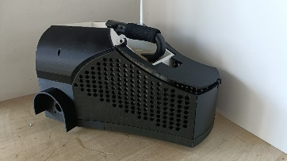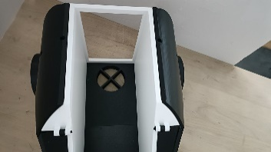
Figure 3 – final assembled design
- Sensors and motors used
- Power supply used

III. DESIGN LIMITATIONS
III.A. Sources
The uniqueness of integrating the Ludlum 9DP Ion Chamber into the design challenge bestowed a limitation on the types of sources our robot could detect. An Ion Chamber detects high levels of ionizing radiation, categorized into particle radiation and electromagnetic radiation. The prior category includes alpha, beta and neutron particles and the latter encompasses gamma rays. Ion Chambers detect, most commonly, gamma rays, due to their high ionizing radiation. Additionally, Ion Chambers can detect high-emitting Beta particulates due to their increased range (which alpha particles lack) (University of Texas, 2013).
These distinctions are integral to identify when selecting a ‘usable’ radioactive source. Our initial provided source was Thorium-232 (Th-232), an alpha-emitting source, with a relatively long half-life, and thus, relatively low activity. As depicted in Fig. 1., there is a 21.7% chance of decay to the ‘first’ gamma energy level of 63.8keV.
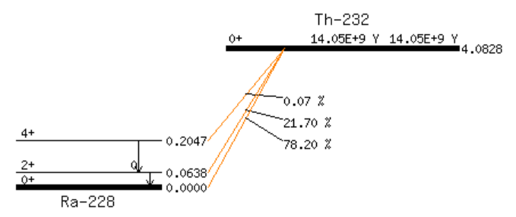
Fig. 1. The decay chain for 90-Th-232, (KAERI, 2014).

Evidently, due to both the low activity paired with the 21% chance of a readable energy output, an Ion Chamber would achieve minimal success with a Th-232 source.
Two alternative sources were suggested as a potential contender, these being natural uranium (238) or an irradiated cesium source (Cs-137).
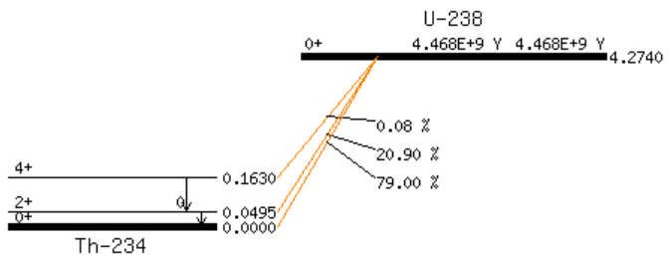
Fig. 2. The decay chain for 92-U-238, (KAERI, 2007).
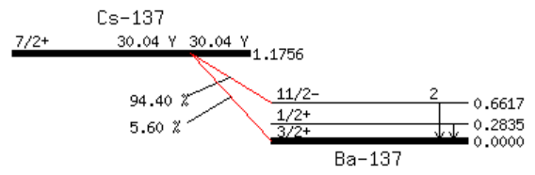
Fig. 3. The decay chain for 55-Cs-137, (KEARI, 2007).

Natural uranium is an alpha-decay dominant isotope, with significantly lower energy emission than the Th-232. Evidently, this source’s compatibility with the ion chamber was, colloquially, non-existent. This left the Cesium source as the viable option, which, paired with the data depicted in Fig. 3., is a high gamma-emitting isotope.

Time restraints for the project, unfortunately, resulted in the restriction of source type to be the thorium-232.

IV. CODING ITERATIONS
The Ludlum 9DP is USB capable, with the ability to output a CSV (comma-separated values) file of the readings, in counts-per-second (cps). The original Capstone group’s use of GPS mapping to plot the position was a great creative solution, which was later built upon (and ‘solved’) by another student in Raspberry Pi. However, our team wanted to represent the data in a different format. A few different solutions were brainstormed: the use of sound detection emitted from the detector, a camera/ lens installed on the robot, further GPS iterations, and the conversion of the CSV data into graphical format.
This final idea was the solution our team wanted to focus on implementing.

Due to the constraints placed by the detector type and source type given to our group, physical application to develop iterative testing for code was made difficult. To begin development, we started with a hypothetical basis. An incredibly simplistic idea based on the original design parameters set for the project: that the robot be able to scan a 12ft x 12ft room in 30 minutes and effectively detect each source. Theoretically, we are given an exact 12ft x 12ft dimensioned room, that the robot must scan in 30 minutes, with unknown spills throughout the room.

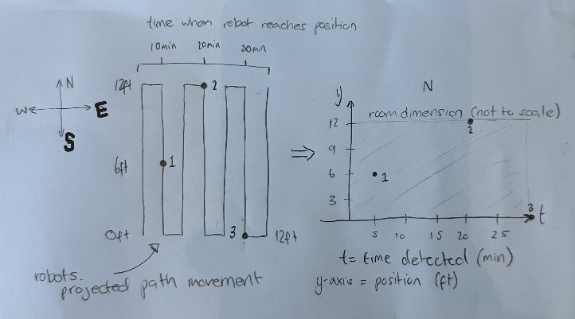
Fig. 4. Visual depiction of the hypothetical physical path to graphical conversion.

Shown in the figure above is the basis for the graphical format. If a room was programmed to specifically to search a 12x12ft room in ‘exactly’ 30 minutes, starting in the south-west corner of the room – facing north. The time correlated would equal the distance covered horizontally, while the robot searches in vertical movement patterns. However, due to the dependence on the robot covering the 144” x 144” space in half an hour, the realistic achievement of this hypothetical must be calculated.
The robot is 11” in width, assuming clearance for the detector is fully covered in those 11”.

$$\frac{144}{11}=13.090909=13.1 vertical scams of the room$$
$$∴7 up, 6 down$$
$$\frac{30 mins=1800 sec}{13.1" }\sim 137.4 sec/sweep$$

Completing a 12ft vertical distance in 2.29 minutes, allows for ~ 12 seconds/ foot as allowance to scan for radioactive material.
$$speed=\frac{distance}{time}$$
$$∴\frac{144 inches}{75 seconds}=1.92ips=9.6fpm$$

$$speed=\frac{distance}{time}$$
$$∴\frac{144 inches}{137.4 seconds}=1.048ips=5.24fpm$$
$$RPM=speed÷wheel circumfrence$$
$$∴RPM=\frac{5.24fpm}{π*0.34f} , diameter=4"=0.333333 feet$$
$$∴4.90572 RPM$$

With a minimum 4.9 RPM required to survey the room in the allotted time-frame - and where generally the RPM range for a line following Arduino is between 200-300RPM – theoretically the robot should be able to map the area in the set time (Arduino, 2011). Now that the RPM is calculated to be viable, the issue arises with if the Ion Chamber can detect a source in the time given (a Gieger Muller counter would be preferred for this time limitation).

V. DISCUSSION
By incorporating a number of significant enhancements, the project successfully improved the prior robot design. While the removal of the steel plate decreased superfluous weight and improved mobility, the development of new tires addressed traction difficulties. More precise radiation detection was made possible by the incorporation of the Ludlum 9DP compensated ion chamber and the reorganization of the wiring, which also enhanced clarity and maintenance. The researchers also improved their source labelling strategy to guarantee that radiation sources could be identified more clearly.
Even with these developments, several restrictions remained. The Ludlum 9DP ion chamber, which is good at detecting high ionizing radiation levels but not so good at detecting low-activity sources like Th-232, was a need for the robot's design. This limitation affected the robot's efficacy in detecting specific radiation kinds. Additionally, because the robot's design was made for a 12 × 12 foot area, it could not be used in larger or more irregularly constructed spaces.
The Ludlum 9DP ion chamber is limited in its ability to identify low-activity sources, even though it is appropriate for detecting large quantities of beta and gamma radiation. Due to its incapacity to amplify signals, specialist low-noise electronics are necessary for low-level radiation detection in order to achieve an effective operational performance. Furthermore, depending on the kind of radiation present, the chamber's design requires a tiny window in order to detect alpha and beta particles, which may be a constraint.

Pros and Cons of Ground Robot Approach
Pros:
- Safety: Utilizing ground robots for radiation detection minimizes human exposure to hazardous environments, enhancing safety for personnel.
- Efficiency: Robots can operate continuously without fatigue, allowing for thorough scanning of areas that might be time-consuming or dangerous for humans.
- Data Collection: Robots can be equipped with various sensors to collect data, providing detailed information about the environment that might be challenging to obtain otherwise.
Cons:
- Terrain Limitations: Ground robots may struggle to navigate rough or uneven terrain, limiting their effectiveness in certain environments.
- Sensor Limitations: The effectiveness of radiation detection can be hindered by the limitations of the sensors used, such as the Ludlum 9DP's reduced sensitivity to low-activity sources.
- Cost and Development Time: Developing and maintaining robotic systems can be costly and time-consuming, requiring specialized knowledge and resources.

Although there are several safety and efficiency benefits to the ground robot approach, it is important to take into account the robot's operating environment and sensor limitations. To optimize the robot's performance in radiation detection duties, future advancements should concentrate on improving sensor capabilities and guaranteeing the robot's terrain adaptability.

VI. CONCLUSIONS
The Radiation Detecting Robot project aimed to improve upon a pre-existing design aimed at creating an autonomous robot. Equipped with the capability of identifying radioactive sources in a 12ft-by-12ft room within 30 minutes, the robot required an entire new build as a foundational step. The team implemented numerous enhancements, such as improved traction, enhanced wire management, and optimized source marking. The reuse of some components, like motors and sonar sensors, allowed for appropriate resource recycling. The greatest challenge the team faced was the integration of the Ludlum 9DP ion chamber as the radiation detector.
However, a significant challenge arose from the detector’s limited compatibility with the provided low-activity Th-232 source, which hindered reliable radiation detection. Despite this, the team developed a hypothetical mapping strategy and calculated the required operational parameters, confirming the robot’s mechanical feasibility. Although physical testing was constrained, the project successfully established a functional foundation for future refinement and practical deployment in radioactive spill detection.

ACKNOWLEDGMENTS
Team 01 would like to acknowledge, first and foremost, Dr. Bahram Nassershariff for assignment and aid with the project. Additionally, appreciation and acknowledgement for the Rhode Island Nuclear Science Centre (RINSC) is noted, with special mention of Sangho Nam and Dr. Cameron Goodwin.

REFERENCES
- E. BROWNE, J. K. TULI, Nuclear Data Sheet 108, 681 (2007)
- KHALIFEH ABUSALEEM, Nuclear Data Sheet 116, 163 (2014)
- atom.kaeri.re.kr. (2000). Table of Nuclides. [online] Available at: https://atom.kaeri.re.kr/old/ton/
- Arduino Forum. (2011). Servo’s speed. [online] Available at: https://forum.arduino.cc/t/servos-speed/56966/10 [Accessed 24 Apr. 2025].
- Gevorg, D.S. (2023). Alpha Particles, Beta Particles, and Gamma Rays. [online] Chemistry Steps. Available at: https://general.chemistrysteps.com/alpha-particles-beta-particles-gamma-rays/ [Accessed 4 May 2025].

APPENDIX
CODE INSERTION

